Nama: Tri Wahyuni

NIM: 2004088

Kelas: SIK A

Mata Kuliah: Pemrograman Web

Tugas: Laporan Pelatihan w3school

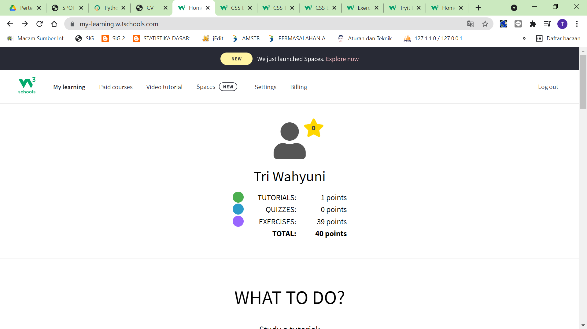

Gambar 1.1 Profil W3SCHOOL

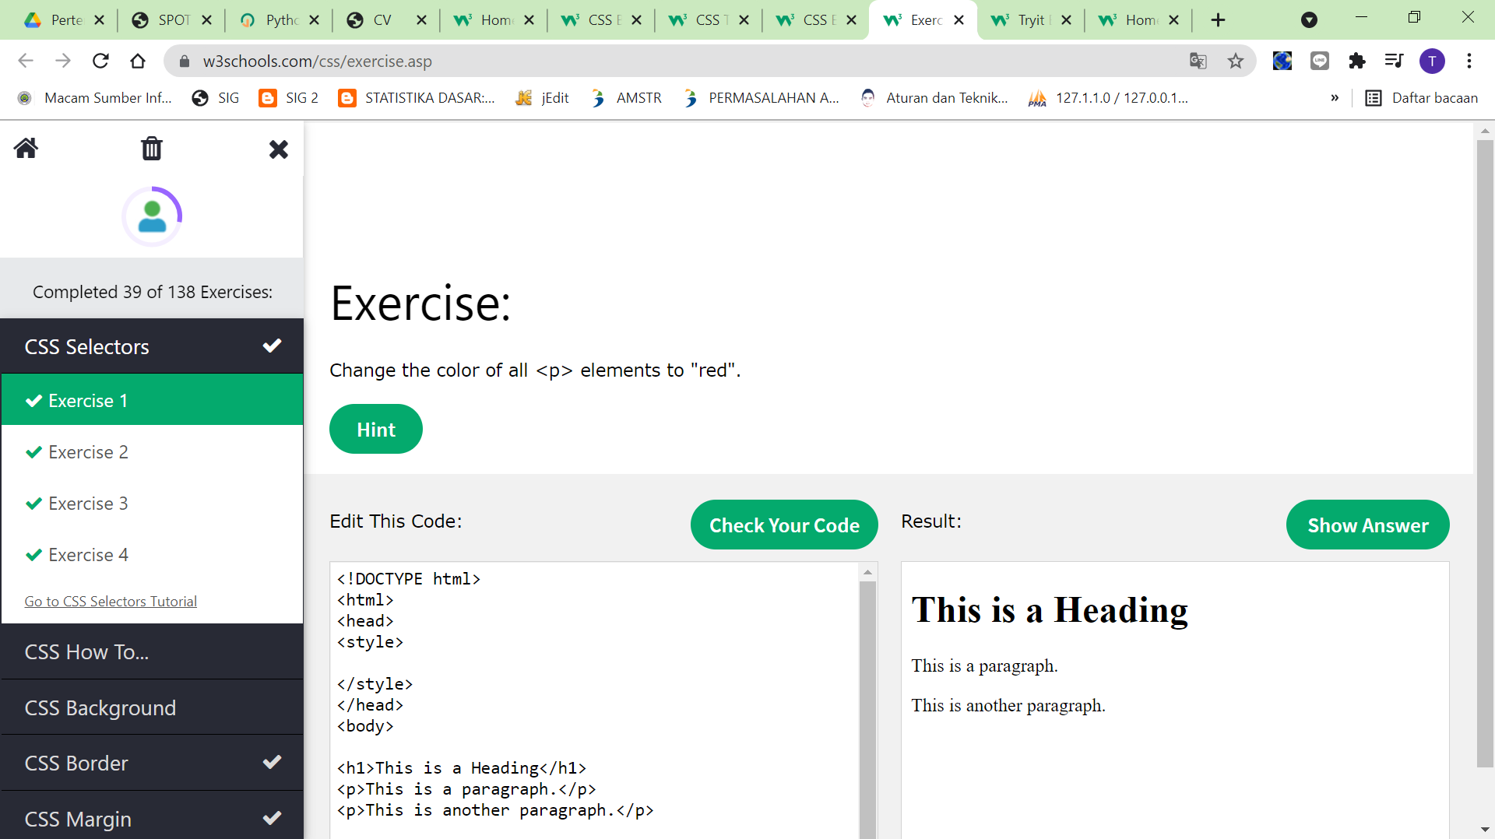

Gambar 1.2 Exercise CSS Selectors

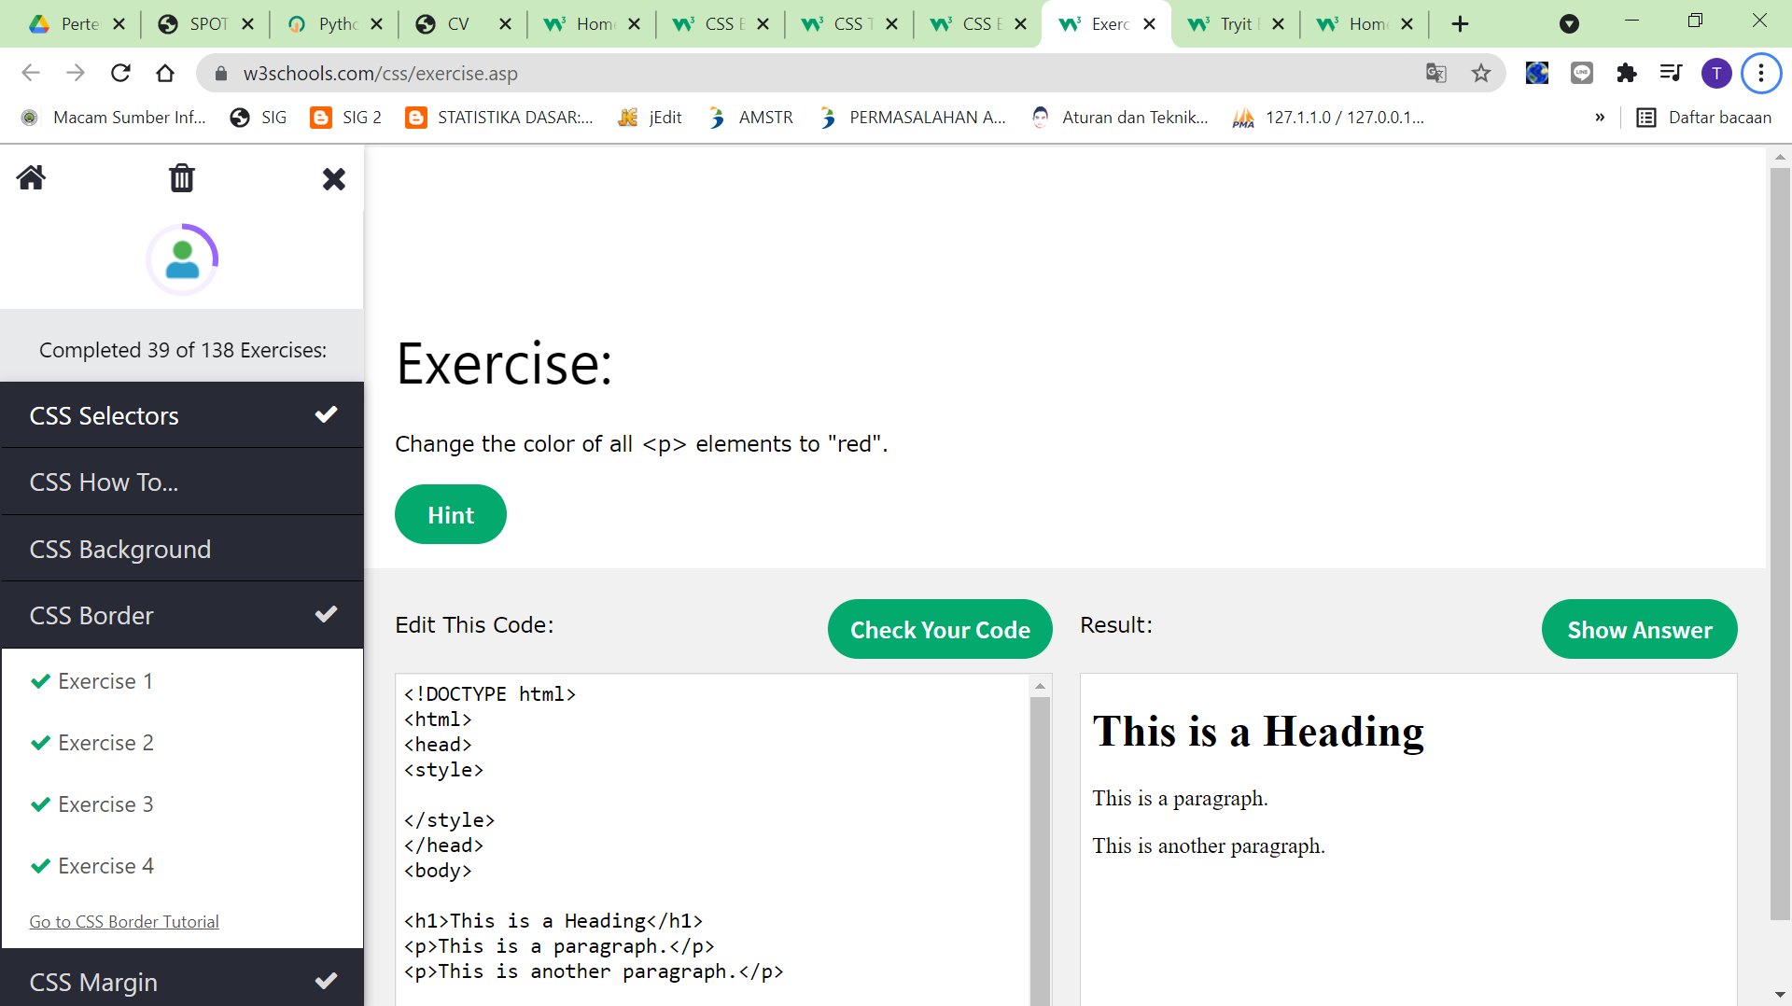

Gambar 1.3 Exercise CSS Border

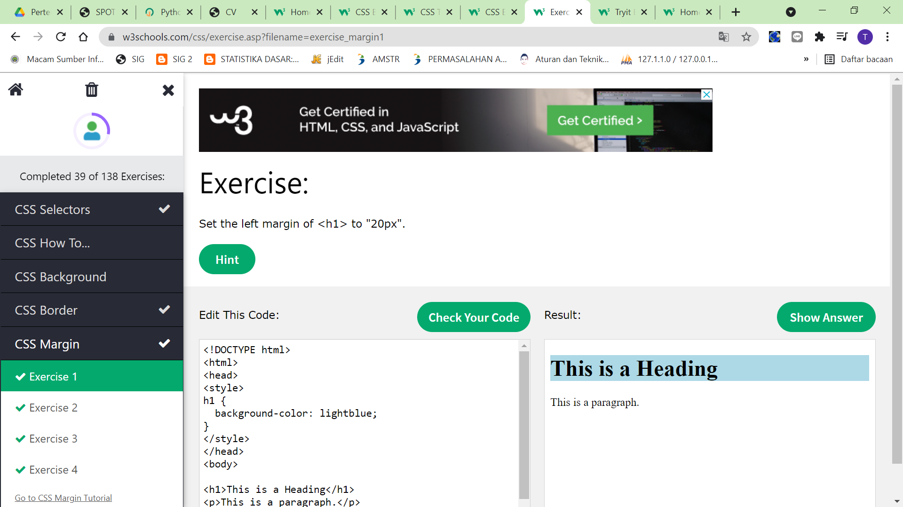

Gambar 1.4 Exercise CSS Margin

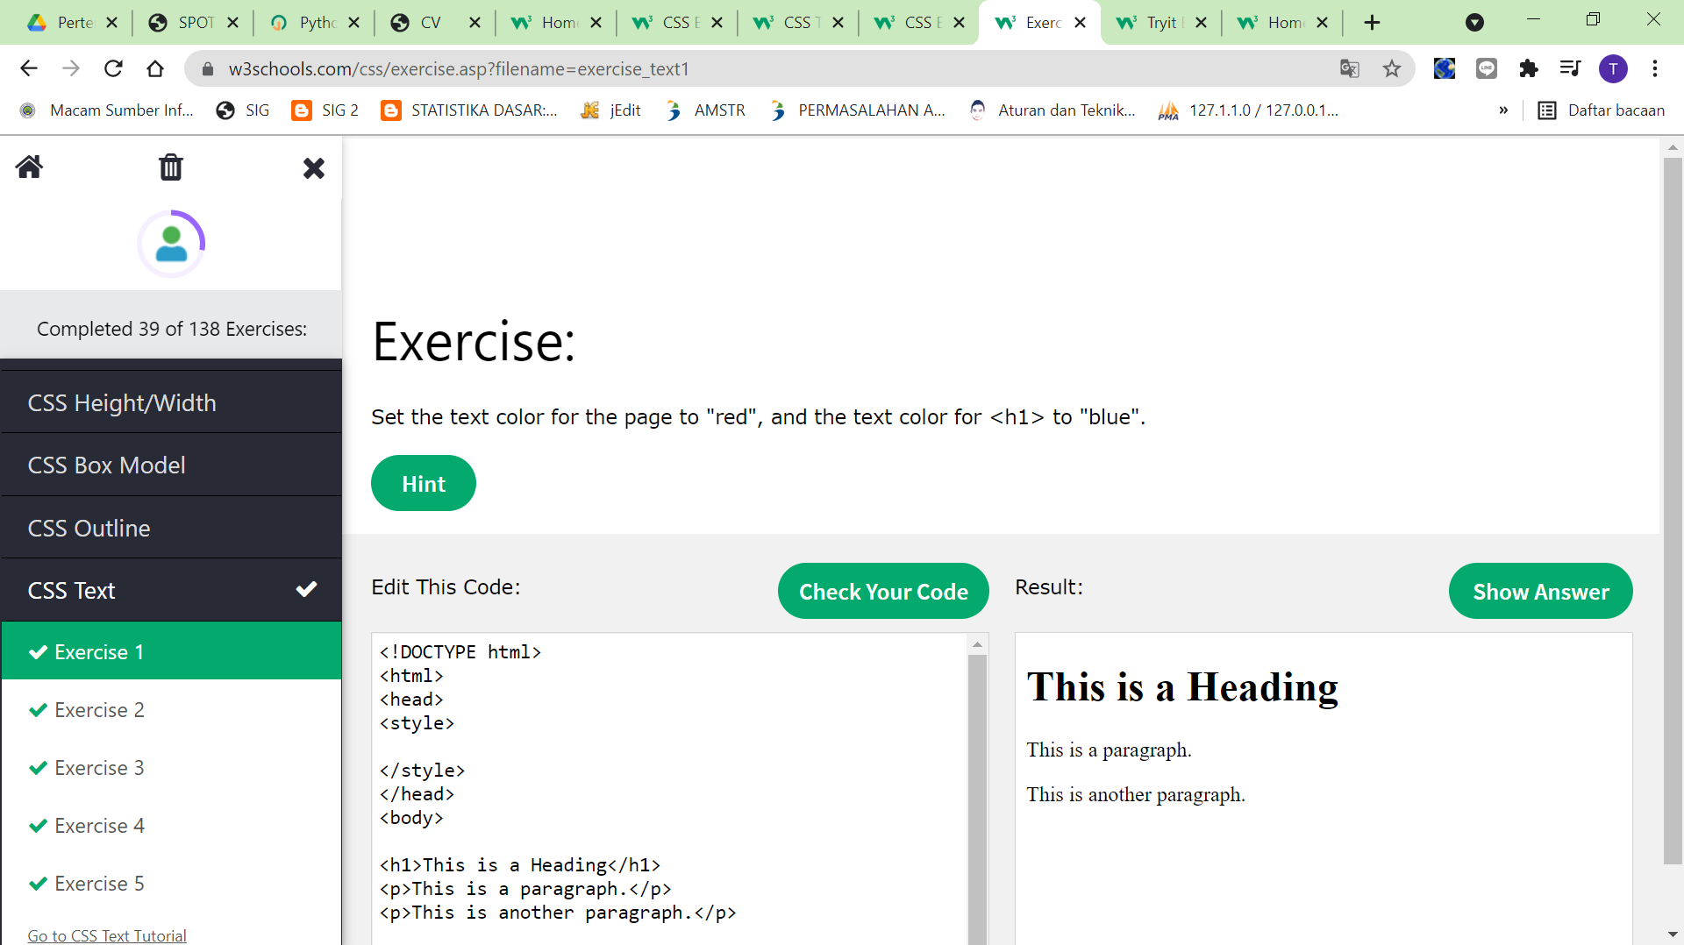

Gambar 1.5 Exercise CSS Text

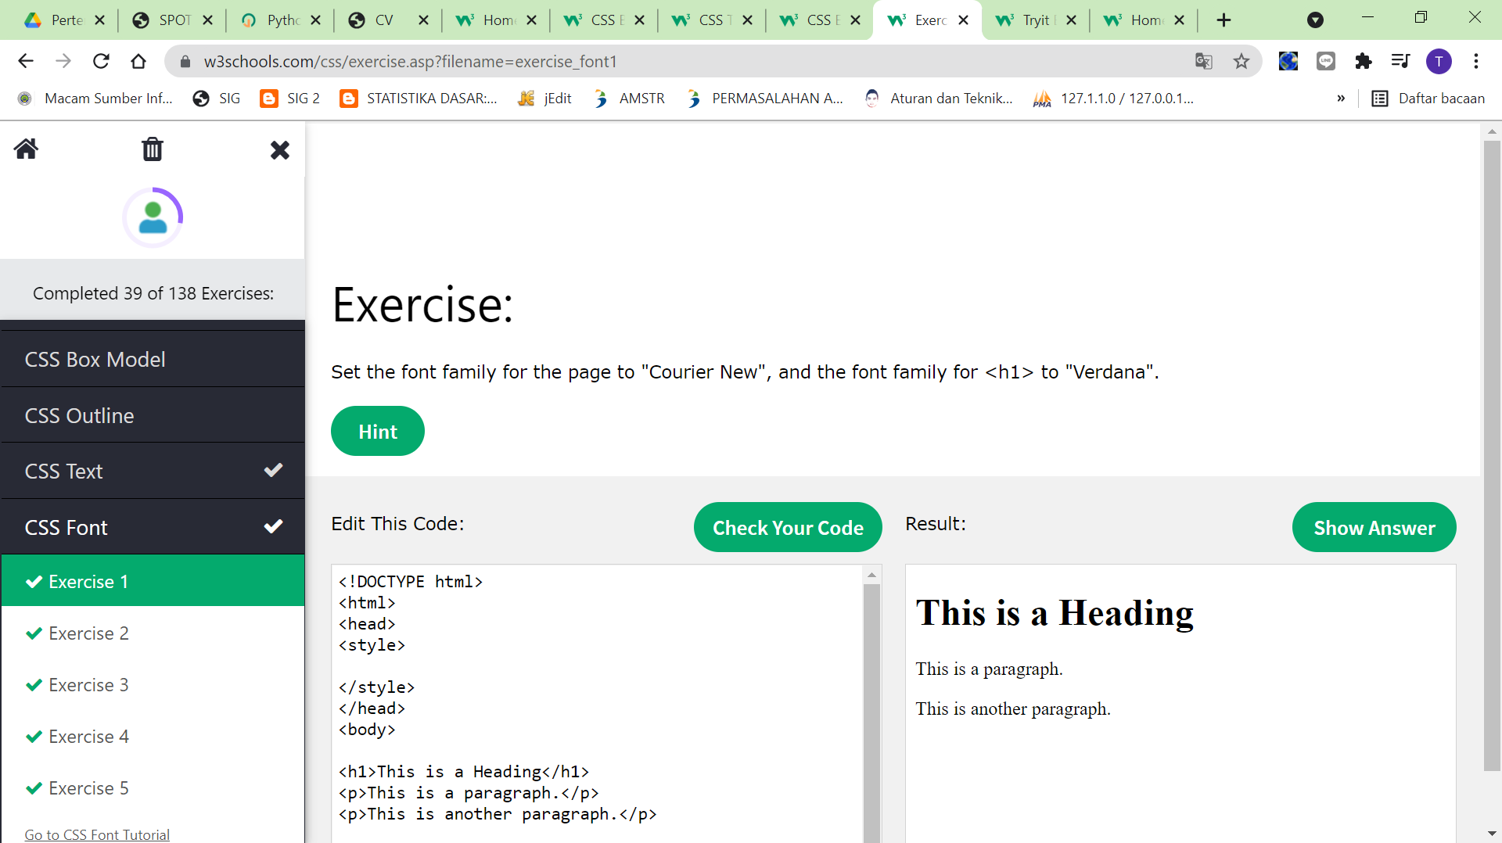

Gambar 1.6 Exercise CSS Font

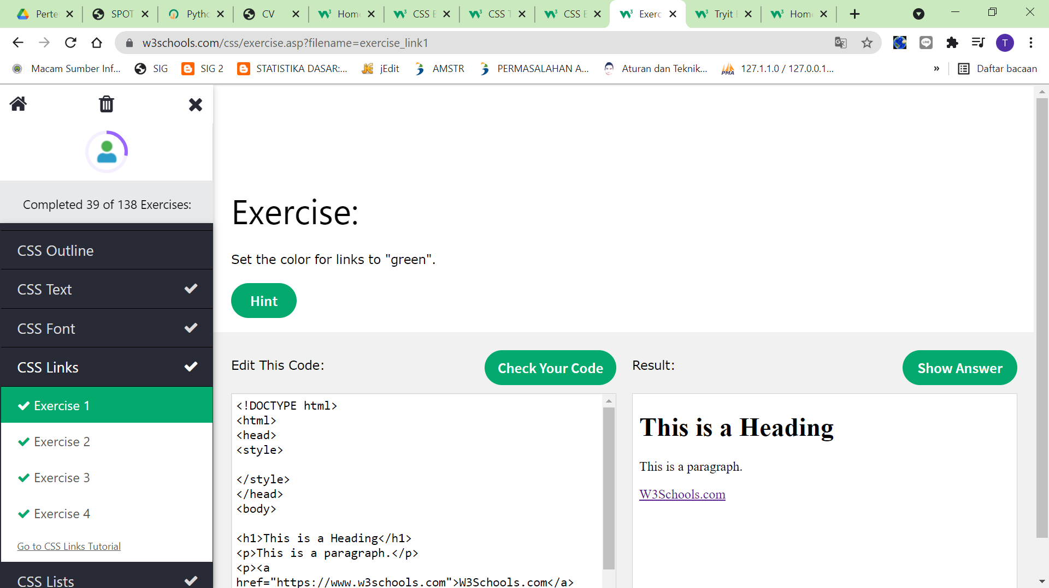

Gambar 1.7 Exercise CSS Links

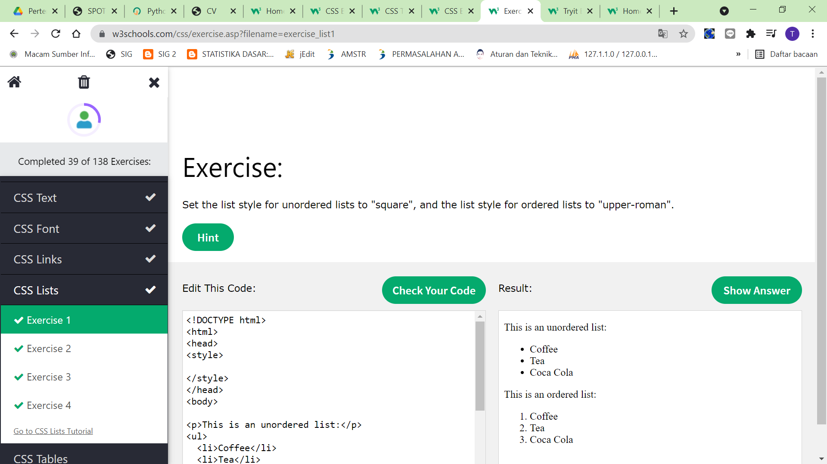

Gambar 1.8 Exercise CSS Lists